**Experiment 5: Flipflops**

Jyothiradithyan k

S3 CSE, 34.

Date: 18/06/21

**AIM**

(a) Development of Verilog modules for SR, JK, T and D flip flops.

**SR flipflop**

**VERILOG CODE**

**Behavioural level**

module SR_ff(

input S,R,clk,clr,

output reg q,qbar);

//intial

always@(posedge clk begin)

begin

if (clr)

begin

q<=1'b0; //nonblocking

qbar<=1'b1;

end

else if((S==1)&&(R==0))

begin

q<=1'b1; //nonblocking

qbar<=1'b0;

end

else if((S==0)&&(R==1))

begin

q<=1'b0; //nonblocking

qbar<=1'b1;

end

else if((S==0)&&(R==0))

begin

q<=q; //nonblocking

qbar<=qbar;

end

else if((S==1)&&(R==1))

begin

q<=1'bx; //nonblocking

qbar<=1'bx;

end

end

endmodule

**Testbench**

`timescale 1ns/1ps

module SR_FFtest;

reg t_S,t_R,t_clk,t_clr;

wire t_q,t_qbar:

SR_ff uut(.S(t_S),.R(t_R),.clk(t_clk),.clr(t_clr),.q(t_q),.qbar(t_qbar));

initial

begin

$dumpvars(1,SR_FFtest);

t_clr=1;

t clk=0;

#10;

t clr=0;

t_S=1;

t_R=0;

#10;

t clr=0;

t_S=0;

t_R=1;

#10;

t clr=0;

t_S=0;

t_R=0;

#10;

t clr=0;

t_S=1;

t_R=1;

#10;

$stop;

end

always

begin

#5 t_clk = ~t_clk;

end

endmodule

**Output**

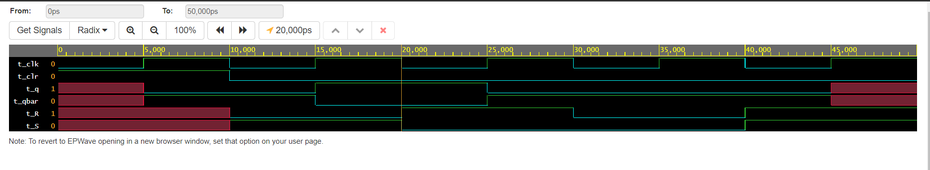

**JK FLIPFLOP**

**VERILOG CODE**

**Behavioural level**

module JK_ff(

input J,K,clk,clr,

output reg q,qbar);

//intial

always@(posedge clk)

begin

if (clr)

begin

q<=1'b0; //nonblocking

qbar<=1'b1;

end

else if((J==1)&&(K==0))

begin

q<=1'b1; //nonblocking

qbar<=1'b0;

end

else if((J==0)&&(K==1))

begin

q<=1'b0; //nonblocking

qbar<=1'b1;

end

else if((J==0)&&(K==0))

begin

q<=q; //nonblocking

qbar<=qbar;

end

else if((J==1)&&(K==1))

begin

q<= ~q; //nonblocking

qbar<= ~qbar;

end

end

endmodule

**Testbench**

`timescale 1ns/1ps

module JK_FFtest;

reg t_J,t_K,t_clk,t_clr;

wire t_q,t_qbar;

JK_ff uut(.J(t_J),.K(t_K),.clk(t_clk),.clr(t_clr),.q(t_q),.qbar(t_qbar));

initial

begin

$dumpvars(1,JK_FFtest);

t_clr=1;

t_clk=0;

#10;

t_clr=0;

t_J=1;

t_K=0;

#10;

t_clr=0;

t_J=0;

t_K=1;

#10;

t_clr=0;

t_J=0;

t_K=0;

#10;

t_clr=0;

t_J=1;

t_K=1;

#10;

$stop;

end

always

begin

#5 t_clk = ~t_clk;

end

endmodule

**Output**

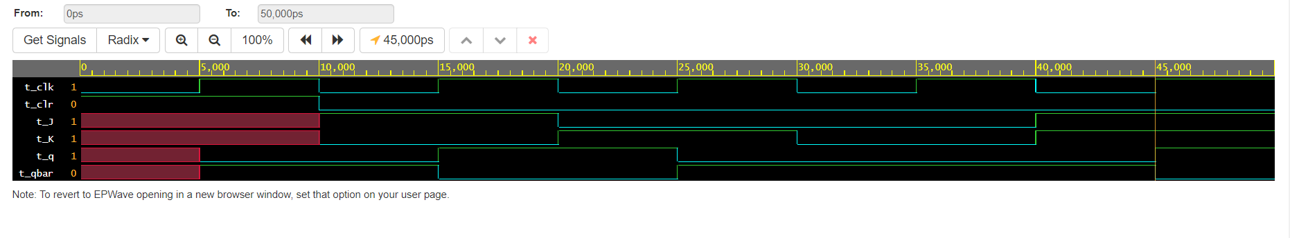

**T FLIPFLOP**

**VERILOG CODE**

**Behavioural level**

module T_ff(

input T,clk,clr,

output reg q,qbar);

//intial

always@(posedge clk)

begin

if (clr)

begin

q<=1'b0; //nonblocking

qbar<=1'b1;

end

else if(T==0)

begin

q<=q; //nonblocking

qbar<=qbar;

end

else if(T==1)

begin

q<= ~q; //nonblocking

qbar<= ~qbar;

end

end

endmodule

**Testbench**

`timescale 1ns/1ps

module T_FFtest;

reg t_T,t_clk,t_clr;

wire t_q,t_qbar;

T_ff uut(.T(t_T),.clk(t_clk),.clr(t_clr),.q(t_q),.qbar(t_qbar));

initial

begin

$dumpvars(1,T_FFtest);

t_clr=1;

t_clk=0;

#10;

t_clr=0;

t_T=1;

#10;

t_clr=0;

t_T=0;

#10;

$stop;

end

always

begin

#5 t_clk = ~t_clk;

end

endmodule

**Output**

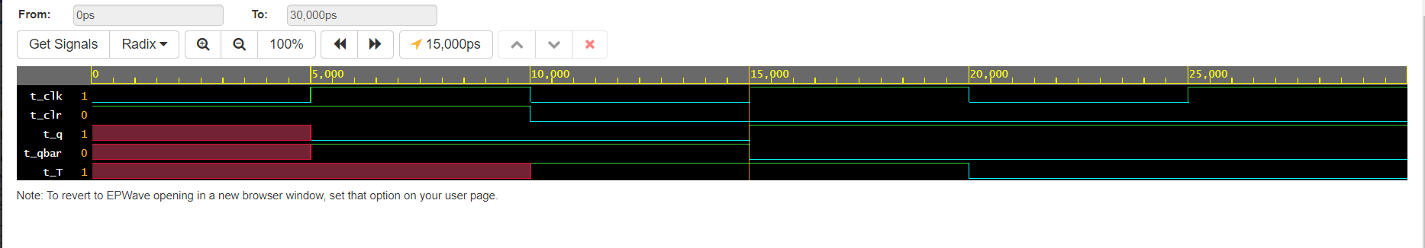

**D FLIPFLOP**

**VERILOG CODE**

**Behavioural level**

module D_ff(

input D,clk,clr,

output reg q,qbar);

//intial

always@(posedge clk)

begin

if (clr)

begin

q<=1'b0; //nonblocking

qbar<=1'b1;

end

else if(D==0)

begin

q<=1'b0; //nonblocking

qbar<=1'b1;

end

else if(D==1)

begin

q<=1'b1; //nonblocking

qbar<=1'b0;

end

end

endmodule

**Testbench**

`timescale 1ns/1ps

module D_FFtest;

reg t_D,t_clk,t_clr;

wire t_q,t_qbar;

D_ff uut(.D(t_D),.clk(t_clk),.clr(t_clr),.q(t_q),.qbar(t_qbar));

initial

begin

$dumpvars(1,D_FFtest);

t_clr=1;

t_clk=0;

#10;

t_clr=0;

t_D=1;

#10;

t_clr=0;

t_D=0;

#10;

$stop;

end

always

begin

#5 t_clk = ~t_clk;

end

endmodule

**Output**

